**ASSIGNMENT ON FLEXBOX**

1. *Use the below html page and name it flexboxAssign1.html*

<html>

<head>

<title>Holy Grail Layout</title>

<link href="https://fonts.googleapis.com/css?family=Ubuntu:300" rel="stylesheet">

</head>

<body id="holygrail" class="container">

<header id="header"> Header </header>

<main id="main" class="container">

<article id="content">

Lorem ipsum dolor sit amet, consectetur adipisicing elit. Similique assumenda voluptatibus debitis quidem dolorem, provident reiciendis, perspiciatis ut consequatur illum aliquid repudiandae aperiam. Iusto reiciendis deserunt illo a harum dolor magni, sunt iure mollitia facere nulla repellat error at, accusamus quam exercitationem rerum fugit blanditiis voluptas odio aperiam temporibus! Delectus inventore eos atque vitae, sunt ea qui assumenda, quos aut aperiam nostrum iusto temporibus in rerum adipisci quidem et consequatur error quod, aliquam minima hic velit similique nemo. Aut voluptatibus reprehenderit autem harum adipisci libero animi quod sapiente veniam fugiat, soluta inventore omnis rerum facere nobis commodi placeat cupiditate assumenda.

</article>

<aside id="secondary">Lorem ipsum dolor sit amet, consectetur adipisicing elit. In iure nulla eaque, explicabo vel fugiat illum, eius debitis cupiditate. Doloremque!</aside>

<aside id="tertiary">Lorem ipsum dolor sit amet, consectetur adipisicing elit. Aspernatur eius eaque ullam eum, dolore ab quasi unde dicta obcaecati libero at placeat facilis dolor natus. Iure, quae consectetur enim eos.</aside>

</main>

<footer id="footer">Footer</footer>

</body>

</html>

1. *The output of the above html page is as below*
2. 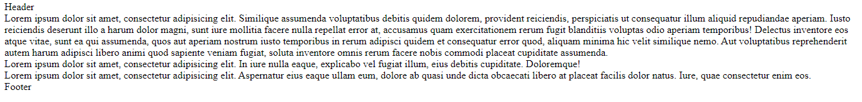
3. *Create two external css files name them as main.css and flexstyle.css.Add the reference of both the css files in flexboxAssign1.html file using the link tag*
4. *Write css in main.css file to get the output as below*

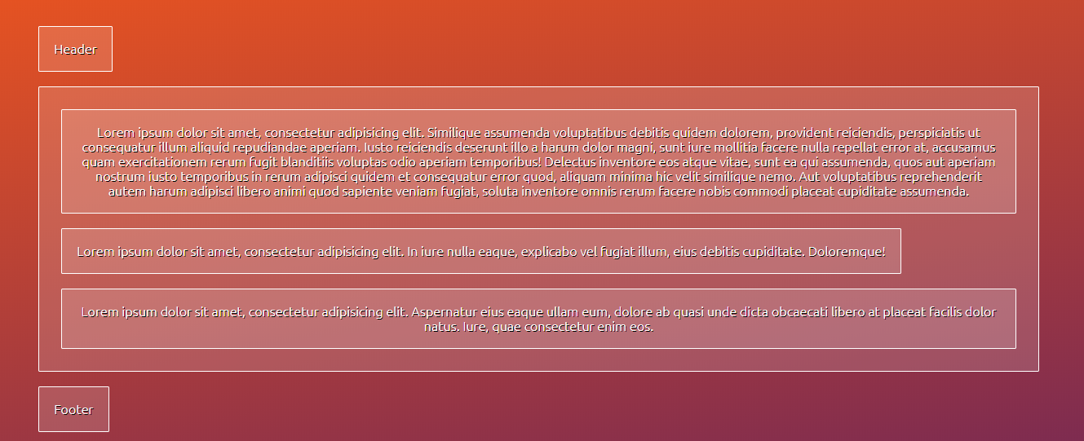

1. *Write css in flexstyle.css to get the final output as below screen shot*

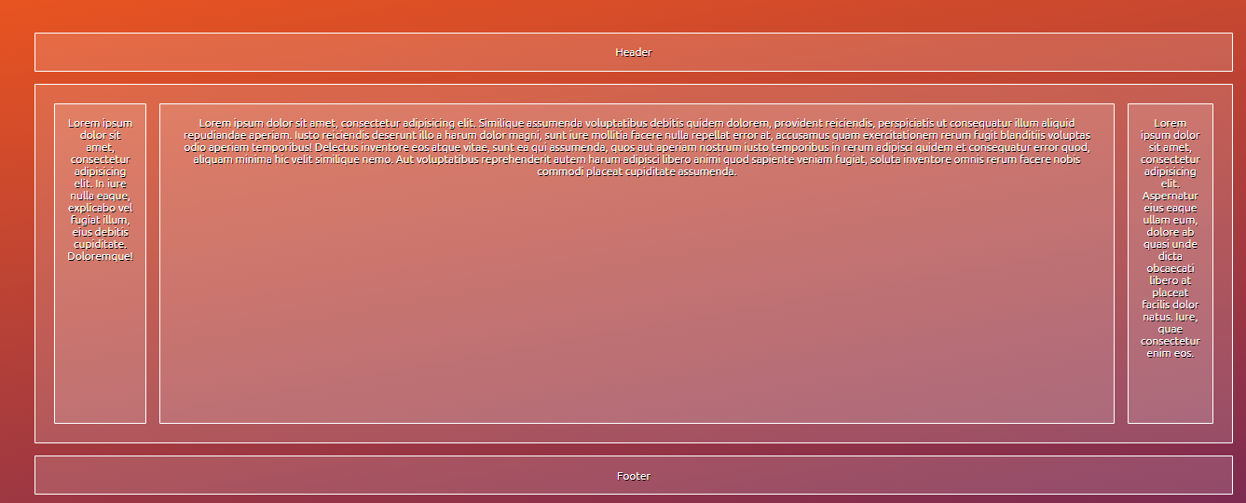

*Note: Colours used are as below*

1. *#772953*
2. *#e95420*
3. *#fff*
4. *rgba(255, 255, 255, 0.15)*
5. *rgba(255, 255, 255, 0.25)*

**ASSINGMENT ON CSS/CSS3 Animation**

1. use the following style.css for this assignment

section, h1 {

margin: 2rem 4rem;

}

.square {

width: 150px;

height: 150px;

background: blue;

position: relative;

}

/* The skew() method */

#skew .square {

background-color: purple;

}

#skew .square:hover {

}

/* The scale() method */

#scale .square div {

background: #000;

position: absolute;

left: 25%;

top: 25%;

width: 75px;

height: 75px;

}

#scale .square div:hover {

}

/* The rotate() method */

#rotate .square {

background-color: tomato;

}

#rotate .square:hover {

}

/* The translate() method */

#translate .square {

background-color: orange;

}

#translate .square:hover {

}

1. use the following index.html

<!doctype html>

<html class="no-js" lang="">

<head>

<meta charset="utf-8">

<meta http-equiv="X-UA-Compatible" content="IE=edge">

<title>2DTransition &amp; Transform | Demos</title>

<meta name="description" content="This is a demonstration about CSS 2D transition">

<link rel="stylesheet" href="style.css">

</head>

<body>

<h1>2DTransition &amp; Transform | Demos</h1><br>

<!-- The skew() method -->

<section id='skew'>

<h3>The skew() method</h3>

<p>skews an element along the X and Y-axis by the given angle.</p>

<div class='square'>

</div>

<hr>

</section>

<!-- The scale() method -->

<section id='scale'>

<h3>The scale() method</h3>

<p>increases or decreases the size of an element.</p>

<div class='square'>

<div></div>

</div>

<hr>

</section>

<!-- The rotate() method -->

<section id='rotate'>

<h3>The rotate() method</h3>

<p>rotates an element clockwise or counter-clockwise according to a given degree.</p>

<div class='square'>

</div>

<hr>

</section>

<!-- The translate() method -->

<section id='translate'>

<h3>The translate() method</h3>

<p>moves an element from its current position. This div element is moved 900 pixels to the right.</p>

<div class='square'>

</div>

<hr>

</section>

</body>

</html>

[PLEASE SCROLL DOWN FOR MORE CONTENT]

1. Below is the screen shot of the above html with css applied

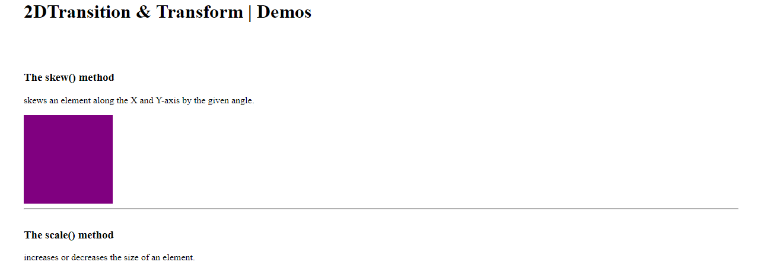

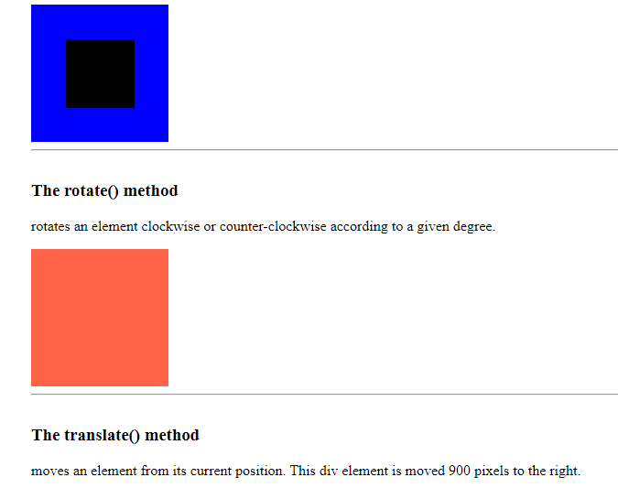



1. The final output should rotate, translate scale and skew the respective squares. Please complete the above assignment by completing the CSS file.